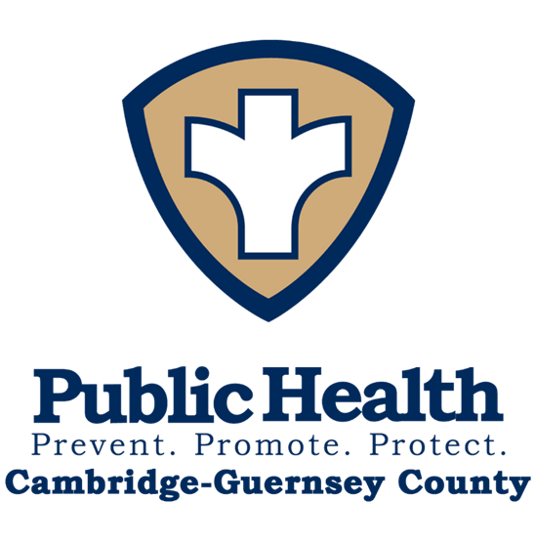

**2024**

**Annual Report**

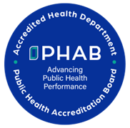

**326 Highland Avenue**

**Cambridge, Ohio 43725**

**740-439-3577**

**www.guernseycountyhealthdepartment.org**

About Us

**Vision**

To be a healthy, safe, and thriving community.

**Mission**

To improve the quality of life for Guernsey County by promoting health, preventing disease, and assuring a safe environment.

**Values**

* **Respectful:** To be understanding of the individual’s values and concerns.
* **Compassionate:** Serving the individual’s needs with empathy and dignity.
* **Equality:** To treat everyone with fairness, without bias.
* **Confidential:** To maintain professional and discrete relationships with the community and staff.
* **Teamwork:** Working as a team and treating each other with respect.

**BOARD OF HEALTH**

The Cambridge-Guernsey County Health Department is governed by a 5-person Board with members appointed by the District Advisory Council and the City of Cambridge. Each member serves a 5-year term and is eligible for reappointment.

Board of Health meetings are held on the 3rd Monday of each month at 5:30 pm, with special sessions called as needed. Meetings are held at the Cambridge-Guernsey County Health Department and are open to the public.

**2024**

**Board of Health Members**

Ellen Kumler, M.D.

Karen Enos

Marilyn Morehead

Mike Yanico

Rebecca Sudduth

**2022 Board of Health Members**

Cliff Maximo, M.D.

Karen Enos

Marilyn Moorehead

Mike Yanico

Rebecca Sudduth

From the Health Commissioner 

The past year has seen some new programs to better the health of our community. Our health department earned national public health accreditation in May of 2024, which required many months of work by our staff. The staff goes above and beyond to serve our community with dignity and compassion. We are waiting to hear the status of our national public health accreditation later this spring.

We continue to partner with our health care partners to keep the community safe and healthy. Much appreciation needs given to our city/county commissioners who support the health department. Also, Kylie Jones, who is our Deputy Health Commissioner, has done an incredible job moving the health department to constantly strive to be better. Together we can all be successful in providing a healthy community we call home.

Edward Colby, D.O.

Health Commissioner/Medical Director

Financial Report

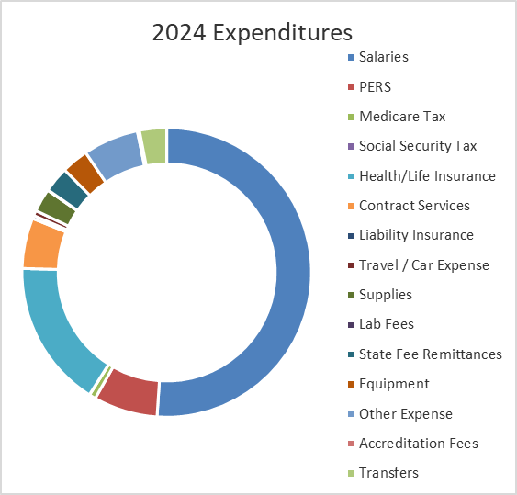

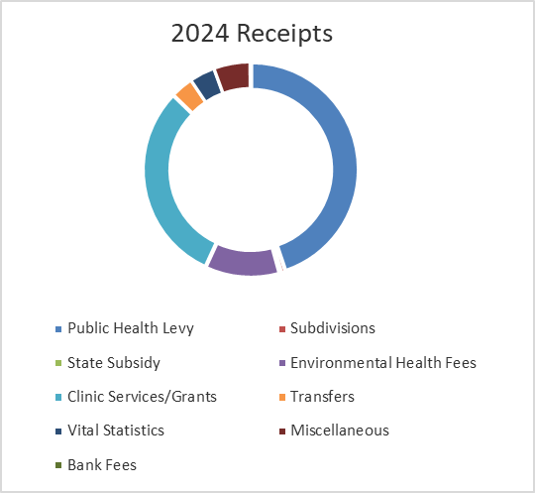



Financial Report and Human Resources

**FUND BALANCE OR CARRYOVER**

The Cambridge-Guernsey County Health Department budgets for revenue and expense for the current year and has cash that is carried over to the next year. Our goal is to keep cash available for any contingencies that may arise (disasters, loss of revenue, etc). By the end of 2024 operating period, the fund balance was $1,307,911.73.

A detailed copy of the annual financial report is available by contacting Kylie Jones MPH, DTR, Deputy Health Commissioner: 740-439-3577 or kjones@guernseycountyhd.org

**HUMAN RESOURCES**

2 Hires

0 Departures

0 Position Open (as of 12/31/2024)

23 Employees on Payroll (12/31/2024)



**BIRTH & DEATH RECORDS**

475 Births Recorded

509 Deaths Recorded

1,766 Birth Certificates Issued

1,532 Deaths Certificates Issued

The Cambridge-Guernsey County Environmental Health Division seeks to improve and promote public health and to assist in maintaining a healthy environment in which is pleasant to live and work. Our department strives to respond to dynamics and growth in Guernsey County while maintaining core public health responsibilities. This is accomplished through development and implementation of programs designed to assist in the promotion of healthy living and the mitigation of environmental factors that can lead to public health nuisance conditions.

Environmental health specialists protect public health through preventative measures designed to identify and control the spread of disease. This is accomplished primarily by the promotion of environmental health through education and through enforcement of local and state public health regulations. Our department provides education, inspections, consultations and enforcement of local, state and federal rules and regulations in accordance with proper policies and procedures.

We have environmental health staff that is dedicated to their job and improvement of public health in Guernsey County. Our unit now utilizes aerial drones for surveillance and obtained remote pilot licensure to operate them. Our county is committed to professional development and attends as many opportunities as possible to further our education and to stay on top of emerging public health issues, while also hosting several in our county. Trainings include pool and spa safety, continuing education class for those in the sewage business and epidemiological response(foodborne) trainings. Our staff is committed to looking out for the 39,000 of Guernsey County and its visitors, and quite often includes over 100,000 in the summer months.

Over 2000 inspections were conducted by Environmental Health staff in 2024.

Ryan Murphy, REHS, Director of Environmental Health

Lindsay Gates, REHS, Environmental Health

Andrea Geilinger, REHS, Environmental Health Specialist

Lisa Leonard, Environmental Health Secretary

Jim Marcentile, Plumbing Inspector

**Food Service**

Environmental Health

|  |  |  |
| --- | --- | --- |
|  | **2023** | **2024** |
| **Food Service Operations Licensed** | 184 | 183 |
| **FSO Inspections** | 381 | 427 |
| **FSO Mobile Licenses** | 28 | 24 |
| **Mobile Inspections** | 85 | 122 |
| **Vending Licenses** | 21 | 18 |
| **Vending Inspections** | 21 | 18 |
| **Retail Food Establishments Licensed** | 122 | 92 |
| **RFE Inspections** | 202 | 233 |
| **Temporary Food Licenses** | 44 | 50 |

**Private Water Systems**

|  |  |  |
| --- | --- | --- |
|  | **2023** | **2024** |
| **Well Permits Issued** | 26 | 23 |
| **Average Depth** | 129 | 122 |
| **Average Gallons Per Minute** | 4.5 | 5.6 |
| **Registered Water Haulers** | 3 | 2 |

Environmental Health



**Public Swimming Pools and Spas**

**Sewage Treatment Systems**

**Plumbing**

|  |  |  |
| --- | --- | --- |
|  | **2023** | **2024** |
| **Installation Permits** | 86 | 94 |
| **Systems Approved** | 87 | 93 |
| **Site Reviews** | 90 | 101 |
| **Sewage System Installers Registered** | 36 | 32 |
| **Service Providers Registered** | 11 | 10 |
| **Septage Haulers Registered** | 16 | 16 |
| **Land Application Permits** | 2 | 2 |
| **Operation Permits Issued** | 86 | 95 |
| **Variances** | 1 | 1 |
| **CEU Class** | 206  Participants | 210  Participants |

|  |  |  |
| --- | --- | --- |
|  | **2023** | **2024** |
| **Commercial Permits Issued** | 32 | 27 |
| **Residential Permits** | 44 | 61 |
| **Master Plumbers Registered** | 24 | 41 |
| **Associate Plumbers Registered** | 13 | 13 |
| **Journeyman Plumbers** | 21 | 30 |

**Solid Waste Haulers**

|  |  |  |
| --- | --- | --- |
|  | **2023** | **2024** |
| **Licensed Haulers** | 4 | 4 |
| **Total Vehicles** | 56 | 60 |

**Body Art**

|  |  |  |
| --- | --- | --- |
|  | **2023** | **2024** |
| Licensed | 4 | 6 |
| Inspections | 4 | 8 |

|  |  |  |
| --- | --- | --- |
|  | **2023** | **2024** |
| **Licensed Pools/Spas/Spray Grounds** | 26 | 25 |
| **Inspections** | 74 | 75 |
| **Operator Trainings** | 1 | 1 |

Environmental Health

**School Inspections**

**Campgrounds/RV Parks**



|  |  |  |
| --- | --- | --- |
|  | **2023** | **2024** |
| **Schools** | 16 | 16 |
| **Inspections** | 32 | 33 |

|  |  |  |
| --- | --- | --- |
|  | **2023** | **2024** |
| **Licensed** | 24 | 25 |
| **Inspections** | 72 | 75 |
| **Temporary Camp Licenses** | 2 | 2 |

**Rabies Prevention/Animal Bites**

|  |  |  |
| --- | --- | --- |
|  | **2023** | **2024** |
| **Animal Bites Investigated** | 127 | 130 |
| **Non-Bite Exposures** | 3 | 0 |
| **Persons Exposed** | 130 | 130 |
| **Specimens sent to ODH laboratory** | 8 | 12 |
| **Positive Cases** | 0 | 0 |
| **Vaccine Treatment** | 14 | 8 |

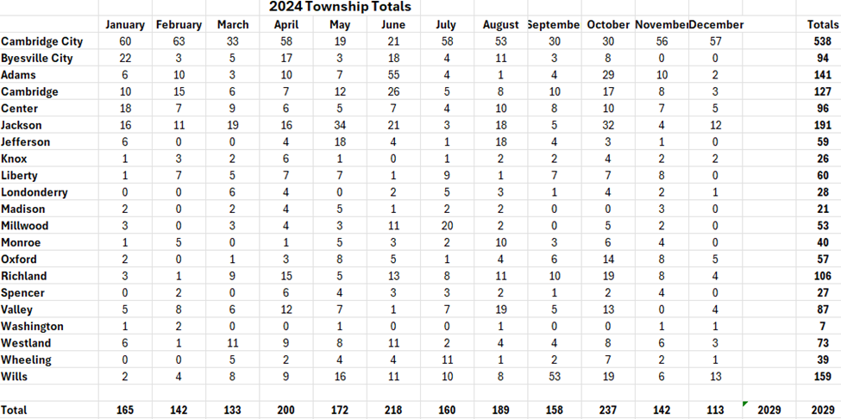

Environmental Health

|  |  |
| --- | --- |
| **WIC STATS** | **2024** |
| Average Guernsey County WIC participants | 946 |
| Average Breastfeeding initiation rate among all WIC moms | 67.5% |
| Average Number of exclusively and partially breastfeeding | 60 |
| Participation increases from 2023-2024 | 29 |

In 2024, the Guernsey County WIC Program was focused on access. Our goals were to increase access to WIC services, increase access to breastfeeding support, and increase access to fresh foods.

Although the number of WIC participants has steadily risen in recent years, many of them face challenges with transportation. We recognized the need to expand our clinic by offering mobile services. To make this happen, WIC staff reached out to local apartment complexes to inquire about using their offices or community rooms as locations for holding clinics closer to where our participants live. We successfully launched a mobile clinic at an apartment complex in Byesville, beginning in November and continuing into the new year. This outreach initiative has allowed us to reconnect with participants who lost access to WIC services due to missed appointments. Looking ahead, we hope to further increase participation in these outreach clinics over the coming year.

The Guernsey County WIC Program has been without a consistent Breastfeeding Peer Helper (BPH) since before COVID. Recognizing the importance of this position for providing breastfeeding education and supporting the growth of our breastfeeding program, we hired a BPH in February, and she is still with us today! She has already launched new programs and is actively educating our participants. Our team works closely together to ensure each participant understands the benefits of breastfeeding. Additionally, we aimed to have all our health professionals become Certified Lactation or Breastfeeding Counselors. Shannon Albrecht, RD, LD, completed lactation training and passed her certification exam! With three breastfeeding-certified health professionals and a Breastfeeding Peer Helper on staff, we are better equipped than ever to support our participants.

We also aimed to increase access to fresh foods. While WIC has offered Farmers' Market Nutrition coupons for many years, we wanted to go a step further. To do this, we introduced a "Plant a Pepper" class and planted a garden for our participants. During the class, attendees planted and took home their own pepper plants. WIC staff provided guidance on selecting soil, choosing hearty plants, and understanding watering and sunlight needs. In May, we planted our WIC Garden using two small areas at the front of the Health Department. We grew tomatoes, two types of peppers, and green onions, and were able to share some of these fresh vegetables with our families. This year, we hope to expand the garden even further.

2024 was a successful year for the Guernsey County WIC Program in terms of improving accessibility. We aim to continue building on these efforts in the coming year, focusing on maintaining and expanding these initiatives while fostering stronger relationships with our participants and the community.

WIC

(Women, Infants and Children)

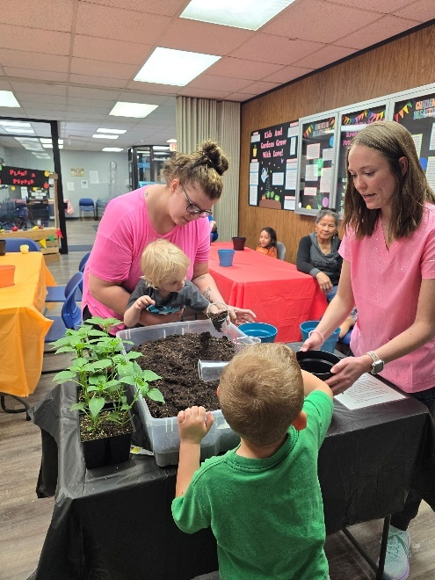

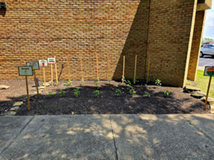

Family & Community

Health & Wellness

**BRIDGES TO WELLNESS**

Bridges to Wellness is a program of Access Tusc which links individuals who have medical, social, and educational barriers to local resources to help them become stronger and healthier. Through Bridges to Wellness, individuals and families can access all the services they need in one place by working with an experienced Community Health Worker who will come to their homes, listen to their needs, and work with them to create a plan to make sure their needs are met.

**Total Participants Served in 2024: 44**

**Total Visits Completed in 2024: 259**

**CHILDREN WITH MEDICAL HANDICAPS**

The Children with Medical Handicaps (CMH) program is a health care program of the Ohio Department of Health. CMH links families of children with special health care needs to a network of quality providers and helps families obtain payment for the services that their children need. The health department deploys two registered nurses to make home visits to families of children with special health care needs and assist physicians and other medical care providers. CMH will pay for diagnostic services for children, regardless of family income.

**2024 Caseload: 247**

**Home Visits/Office Visits: 93**



**CRIBS FOR KIDS**

The Health Department, in partnership with the Perry County Health Department and the Ohio Department of Health, offers a Cribs for Kids program to help prevent the number of sleep related infant deaths in Guernsey County. The Health Department provided education to parents and caregivers on the importance of practicing safe sleep for their babies and by providing portable cribs to families who, otherwise, cannot afford a safe place for their babies to sleep.

**Cribs Distributed in 2024: 17**

**Ohio Buckles Buckeyes**

The overall goal of this program is to increase the availability of child safety seats for families who could not otherwise afford them and to increase correct installation and proper use of child safety seats**.**

**Car seats distributed in 2024: 42**

Family & Community

Health & Wellness



**GENERAL MEDICAL CLINIC**

The Health Department offers a General Medical Clinic for residents of Guernsey County who do not have a primary care physician and who are unable to pay the full cost to see a primary care physician. The clinic is held every Wednesday afternoon. Health Commissioner/Medical Director, Dr. Edward Colby, serves patients by appointment. Sick patients are scheduled as well as those seeking physicals for work, school, etc.

**Number of 2024 visits: 57**

**REPRODUCTIVE HEALTH AND WELLNESS PROGRAM**

The Reproductive Health and Wellness program provides women’s health exams including pap tests, sexually transmitted infection (STI) testing and treatment, clinical breast and pelvic exams, routine lab testing, family planning supplies, education, counseling, and referral services. Male services include: STI testing and treatment, treatment for HPV, education, referral services, and issuing supplies such as condoms.

**Number of Clinics: 40**

**Unduplicated clients served: 305**

**Total duplicated encounters: 791**

Communicable Disease Prevention

**IMMUNIZATIONS**

The health department’s immunization program provides services to prevent and protect the public against vaccine preventable disease. Adult and childhood vaccines were available by scheduled appointment.

**IMMUNIZATION DATA**

**Total Number of VFC Clinics at the Health Department: 94**

|  |  |
| --- | --- |
| **Childhood Adolescent Immunizations** | |
| **Vaccine:** | **Doses Given**: |
| DTaP: | 46 |
| Td | 0 |
| DT | 0 |
| Pediarix | 120 |
| MMR | 33 |
| Influenza | 7 |
| HIB | 124 |
| Polio | 21 |
| Hep B | 7 |
| Tdap | 45 |
| Meningococcal | 69 |
| Meningococcal B | 8 |
| Rotavirus | 45 |
| HPV | 47 |
| Kinrix | 32 |
| Prevnar | 131 |
| MMRV | 37 |
| HEP A | 64 |
| Varicella | 36 |
| RSV | 1 |
| COVID | 1 |
|  |  |
|  |  |

|  |  |
| --- | --- |
| **Adult Immunizations:** | |
| **Vaccine:** | **Doses Given:** |
| Hep B | 3 |
| Td | 0 |
| Influenza | 111 |
| Hep A | 8 |
| Menomune | 0 |
| Twinrix | 0 |
| Tdap | 17 |
| Meningitis | 0 |
| HIB | 0 |
| MMR | 0 |
| Rabies | 0 |
| Varicella | 0 |
| COVID | 44 |
| RSV | 1 |
| Shingles | 2 |
| Prev20 | 2 |

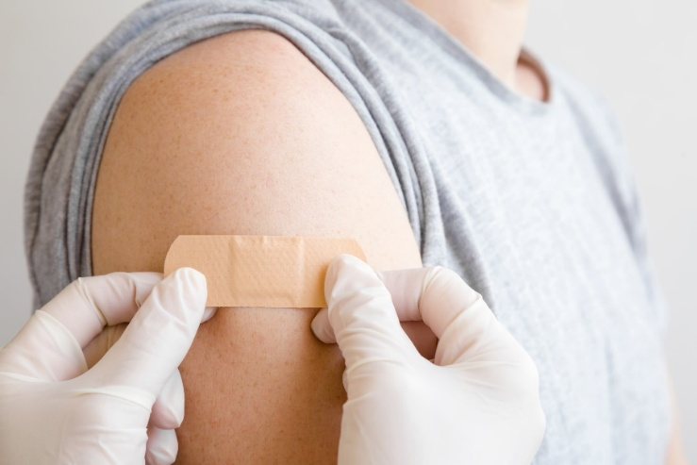

Communicable Disease Prevention

*SARS-CoV-2 data and any condition with < 1 cases were omitted

**SARS-CoV-2**

**2024 Cases**

**855**

*Not included in chart

|  |  |  |  |
| --- | --- | --- | --- |
| **SEXUALLY TRANSMITTED INFECTIONS** | | | |
| Numbers indicate those tested (Male and Female) by health department staff in 2024. | | | |
|  |  |  |  |
| **Disease** | **Tested** | **Positive** | **Percent Positive** |
| Chlamydia | 186 | 17 | 9.13% |
| Herpes | 2 | 1 | 50% |
| HIV | 77 | 0 | 0% |
| HPV | 40 | 10 | 25% |
| Gonorrhea | 186 | 2 | 1.07% |
| Syphilis | 77 | 1 | 1.29% |

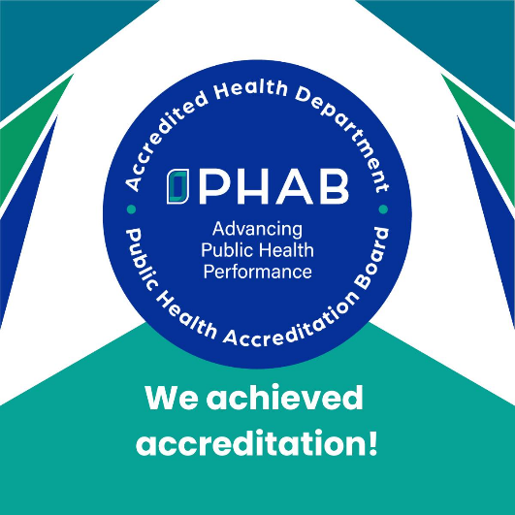

**Public Health Accreditation**

**EXCITING NEWS!**

The Cambridge-Guernsey County Health Department achieved national accreditation status through the Public Health Accreditation Board. Accreditation is a rigorous process that shows our commitment to quality and performance improvement, collaboration, and public health practice. We are proud to have our work and programs nationally recognized and remain committed to the health and wellbeing of our community.

**Community Health Assessment and Community Health Improvement Plan**

The health department has contracted with Illuminology to assist in the facilitation and creation of the 2024 Community Health Assessment and the Community Health Improvement Plan. The 2024 process included a kick-off meeting, collection of secondary data, focus groups in the community and key informant interviews. The Community Health Assessment draft was published and published for review and feedback. Next steps include the prioritization process of health issues. The assessment and plan are completed every 3-5 years, they inform and guide community strategies to improve public health.

**Strategic Planning**

The health department will be looking to contract for the facilitation of a new strategic plan in 2025.

**FOLLOW US ON SOCIAL MEDIA**



**@GUERNSEYCOUNTYHEALTHDEPARTMENT**



**@GUERNSEYCOUNTYHEALTHDEPARTMENT**

Thank you for your continued support.